Battle Arena – A Java OOP Project

# Index

* 1. Introduction
* 2. Libraries and Frameworks
* 3. Bottom-Up Design Overview
* 4. Class Interactions (with Diagram Summary)
* 5. OOP Concepts in Practice
* 5.1 Encapsulation
* 5.2 Information Hiding
* 5.3 Polymorphism
* 5.4 Composition
* 5.5 Reuse
* 5.6 Abstraction
* 5.7 Inheritance
* 5.8 Subtyping
* 5.9 Exception Handling
* 5.10 Strategy Pattern
* 5.10.1 Diagrams
* 5.11 Factory Pattern
* 6. Additional Complexity Features
* 6.1 Multiple players
* 6.2 AI-Assisted Gameplay
* 6.3 Environmental Obstacles
* 6.4 Dynamic Bonuses
* 6.5 Level Progression System
* 6.6 Exception Handling and Game Logic Enforcement
* 7. Conclusion

# 1. Introduction

Battle Arena is a turn-based combat simulation game developed in Java. The game models a system where heroes automatically battle AI-driven enemies across multiple levels with varying challenges like traps, obstacles, and dynamic bonuses. The project showcases the complete application of object-oriented programming (OOP) principles through carefully structured, modular code.

# 2. Libraries and Frameworks

The game is developed in Java 17 using IntelliJ IDEA. Maven is used for dependency and project management. Only Java standard library java.util.List is used, which contains utility classesand interfaces that enable storingand processing of large amounts of data. No third-party frameworks were required.

# 3. Bottom-Up Design Overview

The system starts with classes such as Hero, Enemy, Weapon, Bonus, and Obstacle. Interfaces define common behavior (IBonus, IEnemy), and abstract classes such as Enemy provide shared logic. These classes are assembled into a Level, and levels are managed by LevelManager. The game runs without player input—heroes and enemies interact based on coded logic.

# 4. Class Interactions

Entities interact through method calls, interface references, and modular factories. Each Hero has a Weapon (composition), and Level instances contain lists of Enemies, Bonuses, and Obstacles. Enemies use the **Strategy Pattern** (AttackStrategy) to determine combat behavior dynamically. Each Enemy tracks its current condition using the EnemyState enum (AGGRESSIVE, DEFENSIVE, FLEEING), which is evaluated at runtime based on remaining health. The assigned EnemyState directly influences which AttackStrategy is selected, enabling adaptive and polymorphic behavior. BonusSelector dynamically applies bonuses based on hero health, and ObstacleFactory adjusts wall and trap impact depending on game difficulty. The entire gameplay sequence is orchestrated by LevelManager.

**(Diagram: Hero → Weapon, Hero → IBonus, Enemy → EnemyState → AttackStrategy, Level → Enemy/Bonus/Obstacle, Enemy ← Zombie/Ogre, Enemy ← Strategy)**

* Flow Diagram

What it shows:

**Main** calls factories → builds all level content

**LevelManager** controls game flow

**Level** handles everything in order:  
Trap → Wall → Bonus → Enemy → Hero → End

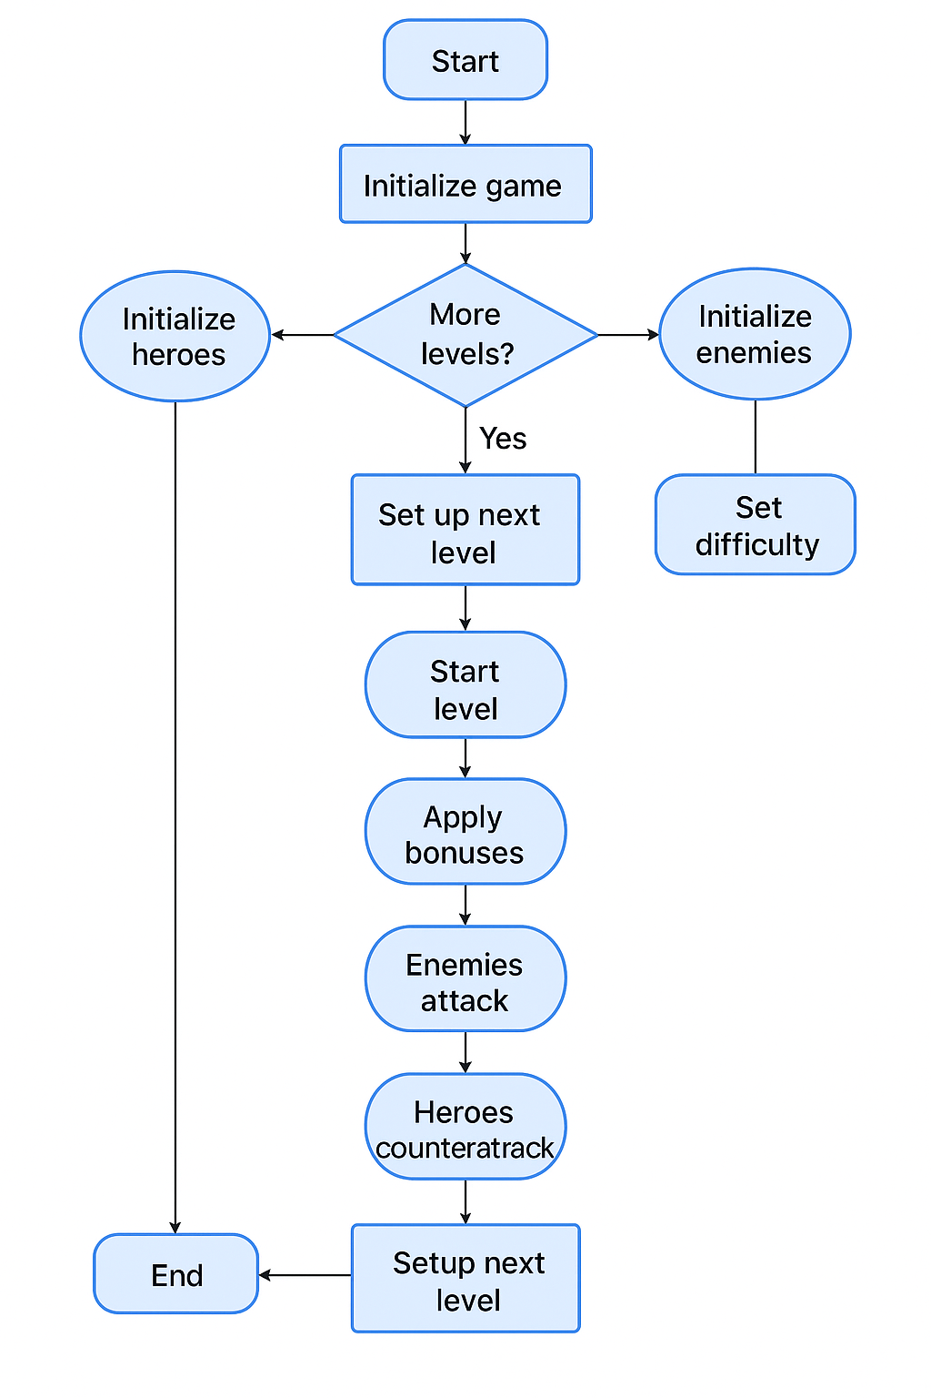

* UML Class Diagram

What it shows:

Inheritance: Zombie and Ogre → Enemy

Strategy use: Enemy→ EnemyState → AttackStrategy→Aggressive/AreaDamageStrategy

Bonuses: Hero uses IBonus → HealthBoost, DamageBoost

Composition: Level has all game components

LevelManager manages Level

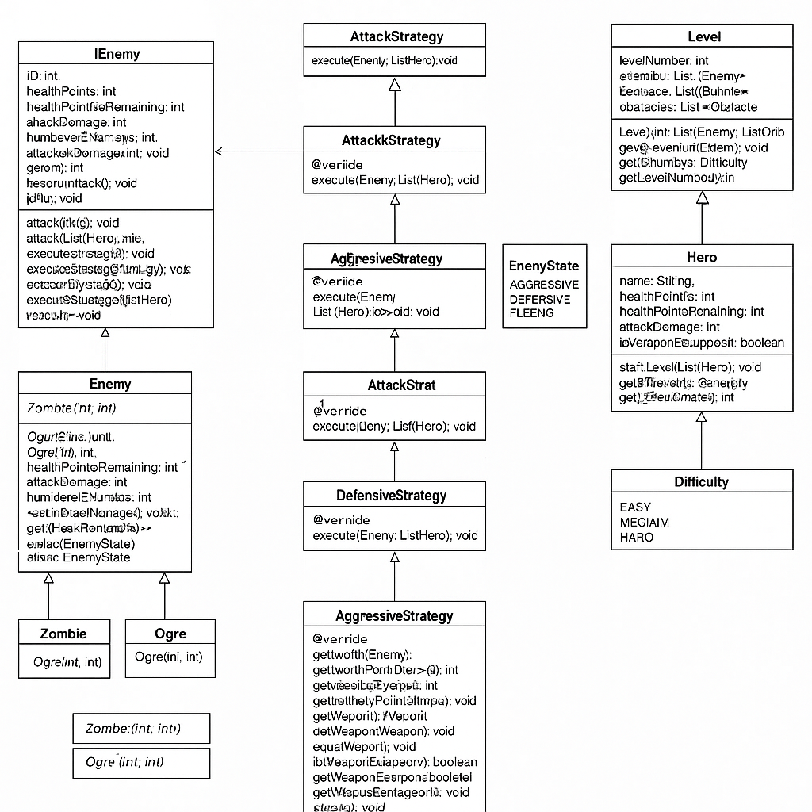

# 5.1 Encapsulation

**Definition**: Encapsulation is the practice of bundling data with methods that operate on that data, while restricting direct access to internal variables.

**In Battle Arena**: All fields in core classes are declared private and are accessed/modified only via public getters and setters. This ensures data safety and separation of internal representation.

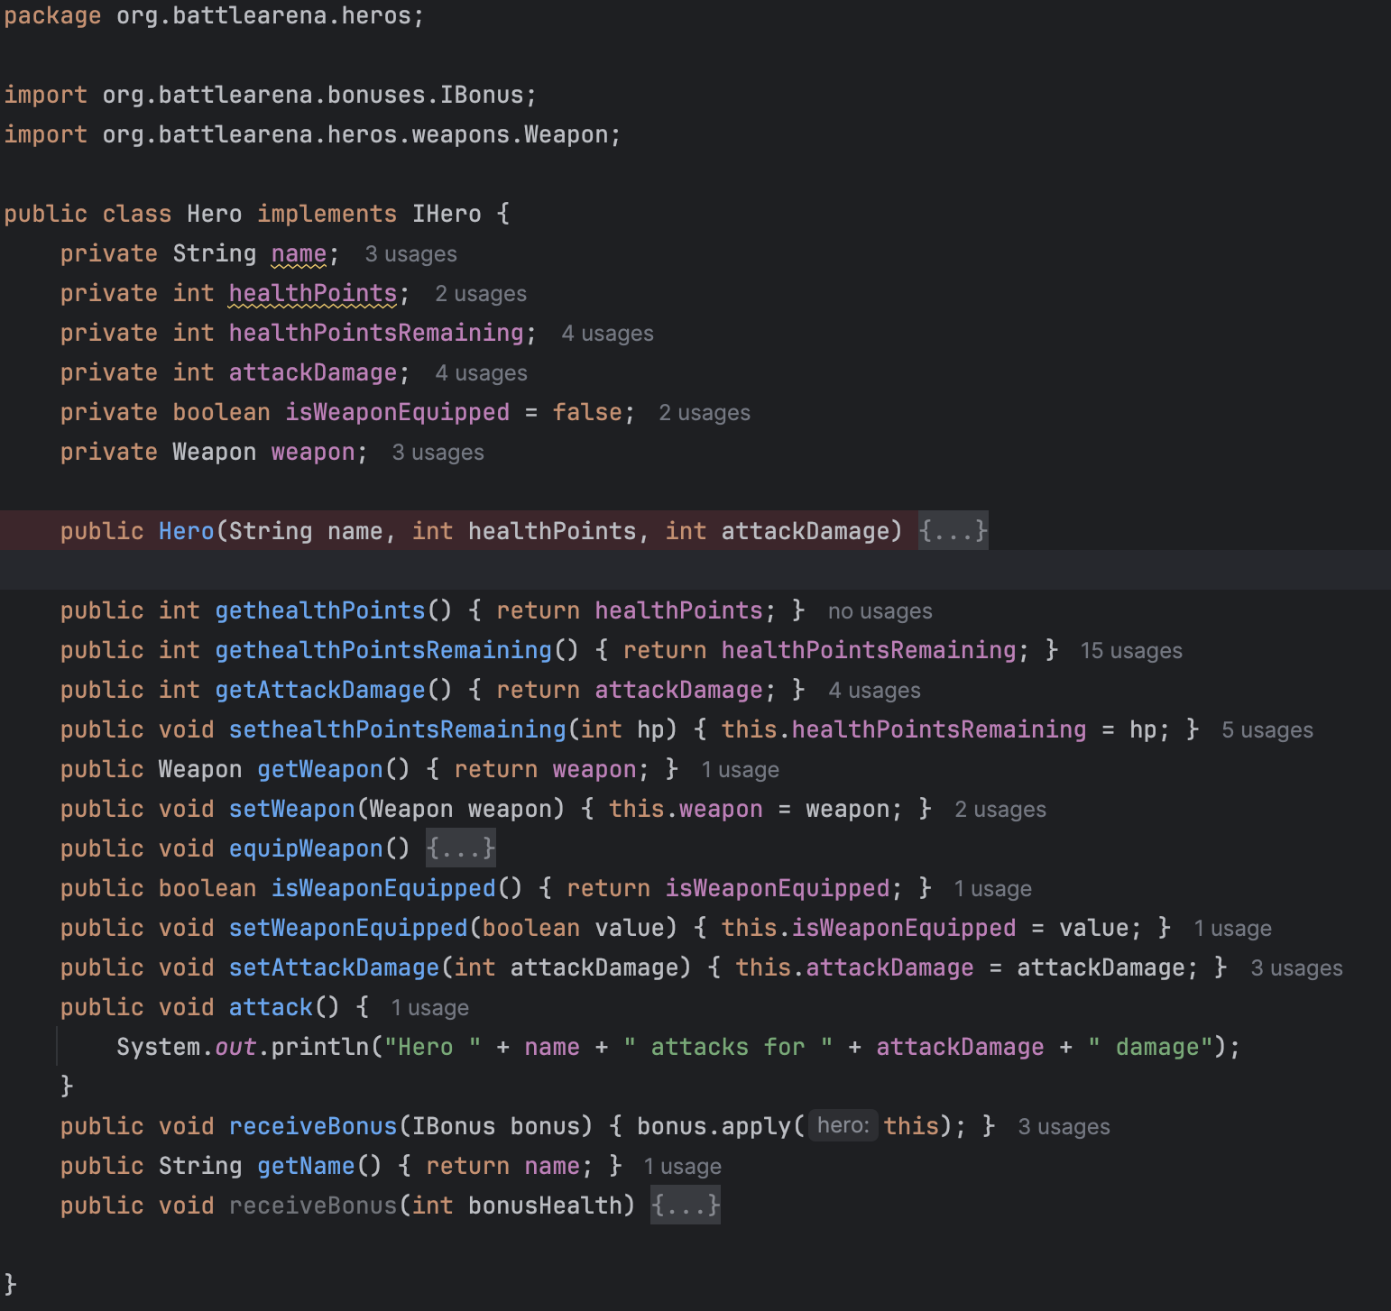

# 5.2 Information Hiding

**Definition**: Information hiding prevents external classes from relying on the internal workings of a class.

**In Battle Arena**: Heroes apply bonuses without knowing their logic, and obstacles are triggered through interfaces.

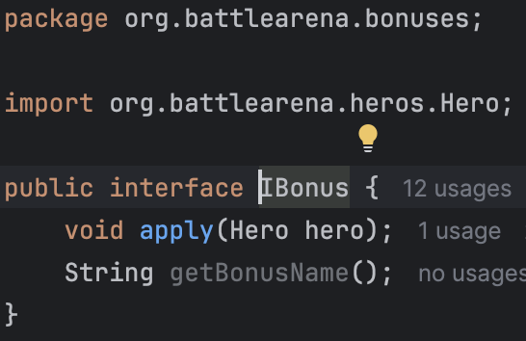

# 5.3 Polymorphism

Polymorphism is shown through overriding methods like specialAttack(), and by processing objects through interfaces like List<IBonus> or List<IEnemy>. The correct version of apply() or attack() is resolved at runtime.

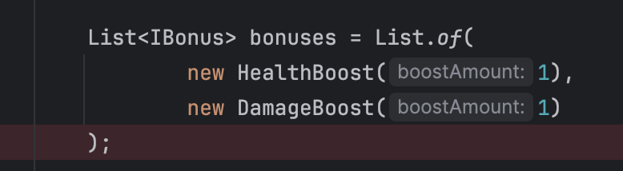

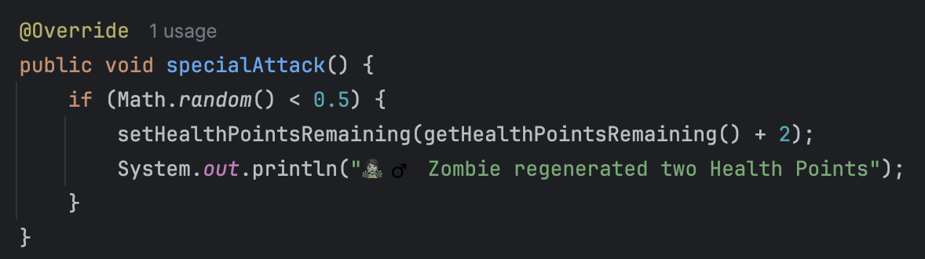

Additionally, polymorphism is achieved using a Strategy Pattern that allows enemies to determine their behavior dynamically. Each Enemy has a reference to an AttackStrategy interface, which is implemented by classes such as AggressiveStrategy, DefensiveStrategy, and AreaDamageStrategy. These enable polymorphic execution of different attack() logics without modifying the enemy class itself.

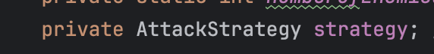

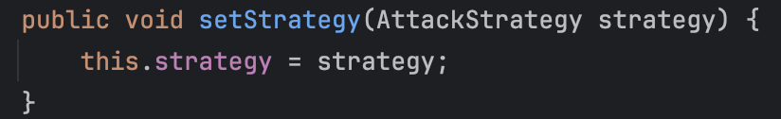

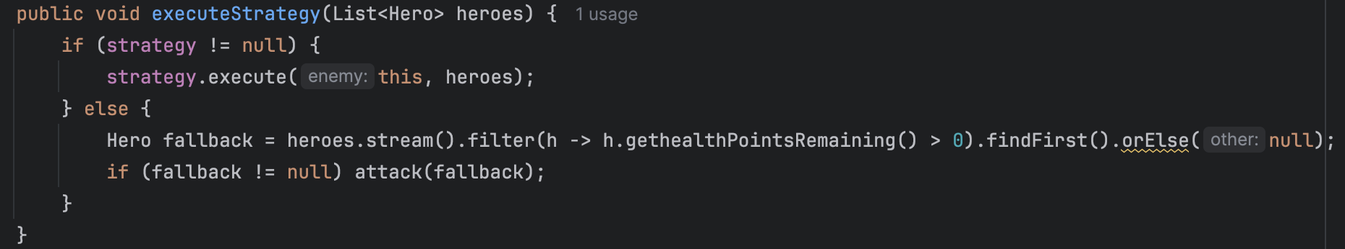

# 5.4 Composition

Hero has a Weapon (object in a field), and Level has lists of Enemies, Bonuses, and Obstacles. These demonstrate has-a relationships central to composition.

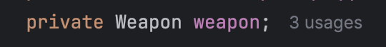

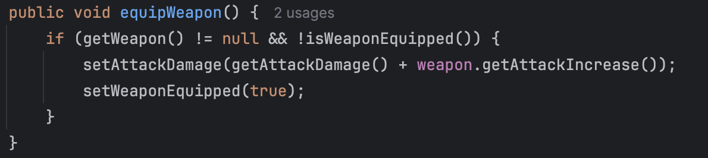

# 5.5 Reuse

Shared behaviors such as attack() and setHealthPointsRemaining() are defined in Enemy and reused in Zombie and Ogre. Similarly, bonus logic is reused through IBonus interface implementations.

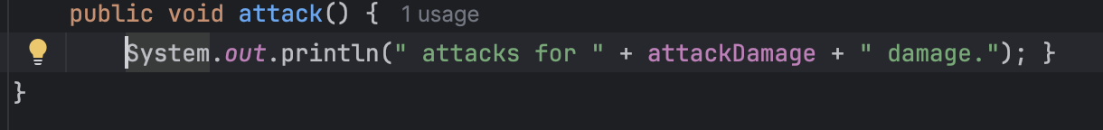

# 5.6 Abstraction

**Definition**: Abstraction hides the implementation details while exposing a clean API.

**In Battle Arena**:

* Interfaces like IBonus, IObstacle and abstract class Enemy define contracts for implementation.

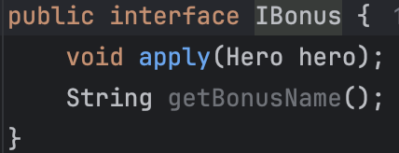



# 5.7 Inheritance

**Definition**: Inheritance allows one class to acquire properties and methods from another.

**In Battle Arena**:

* Enemy is inherited by Zombie and Ogre
* specialAttack() is overridden in each subtype

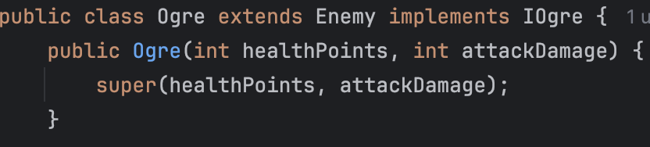

# 5.8 Subtyping

Code uses interfaces as types:  
List<IBonus> bonuses = List.of(new HealthBoost(), new DamageBoost());  
Subtypes are interchangeable through interface references.

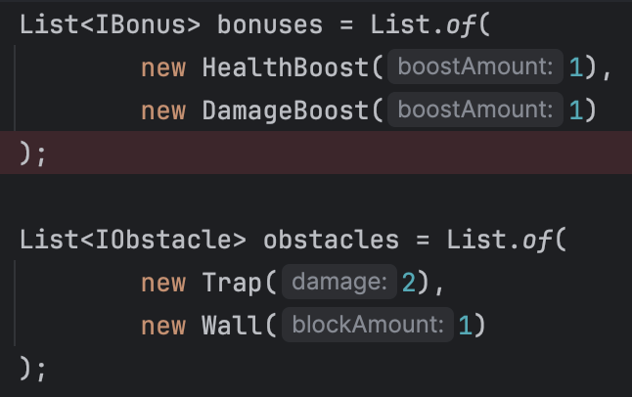

# 5.9 Exception Handling

**Definition**: Exception handling allows programs to catch and deal with errors gracefully. CharacterDeadException is thrown when a hero's HP drops to 0. This exception is caught in LevelManager to stop the game and display an appropriate message.

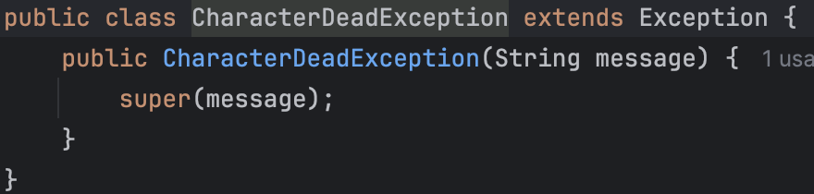

# 5.10 Strategy Pattern

The Strategy Pattern is used to enable flexible and interchangeable enemy behavior. Each enemy can be assigned a strategy implementing AttackStrategy, such as:

* AggressiveStrategy: targets the strongest hero
* DefensiveStrategy: targets the weakest
* AreaDamageStrategy: targets all heroes

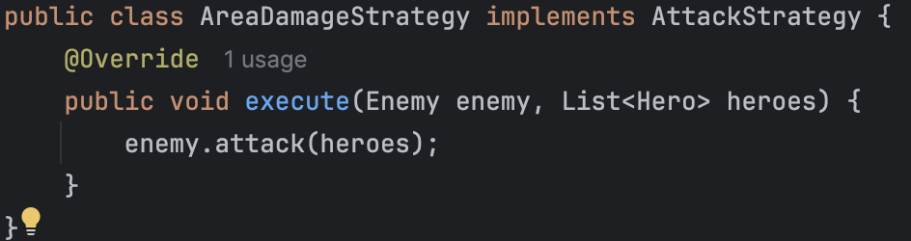

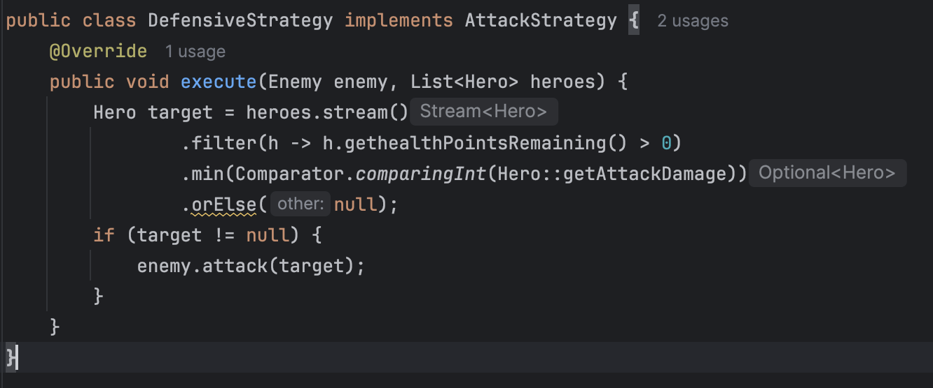

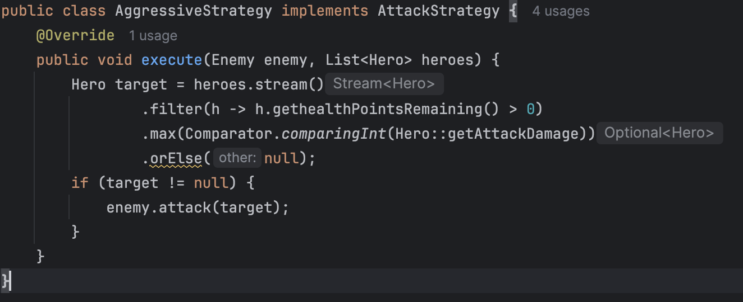

To enhance adaptive behavior, each Enemy is also assigned an EnemyState (AGGRESSIVE, DEFENSIVE, FLEEING).  
The state is determined dynamically during combat based on the enemy’s remaining health and is used to assign an appropriate AttackStrategy.  
For example, enemies with less than 30% health enter the FLEEING state and adopt the FleeStrategy, skipping attacks to survive.  
This creates a synergy between state-driven logic and strategy-based polymorphism.

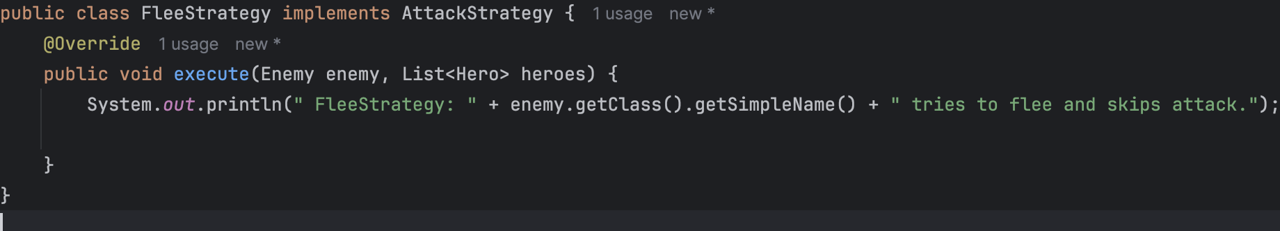

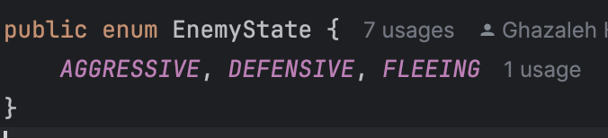

# 5.10.1 Diagrams

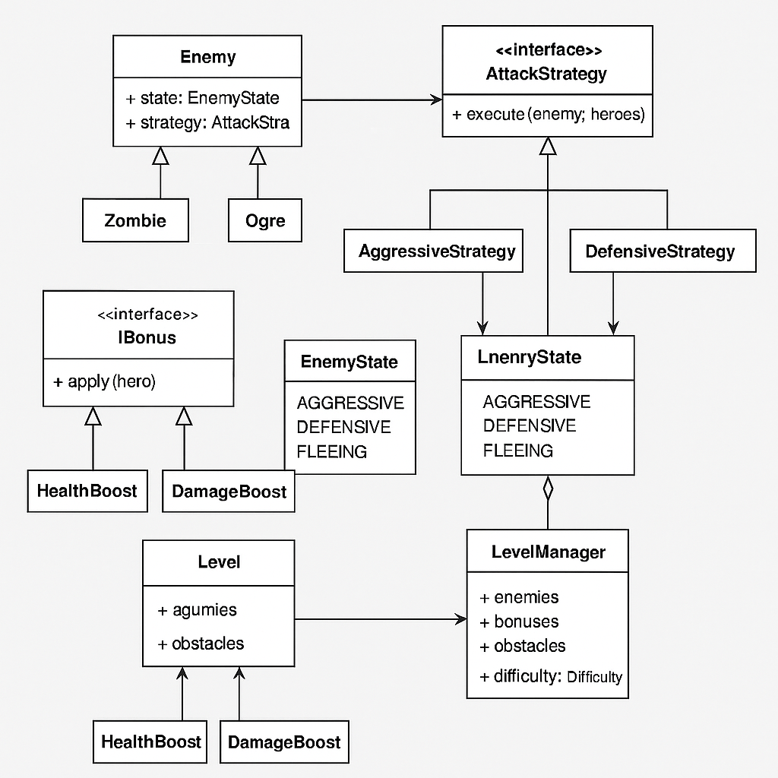

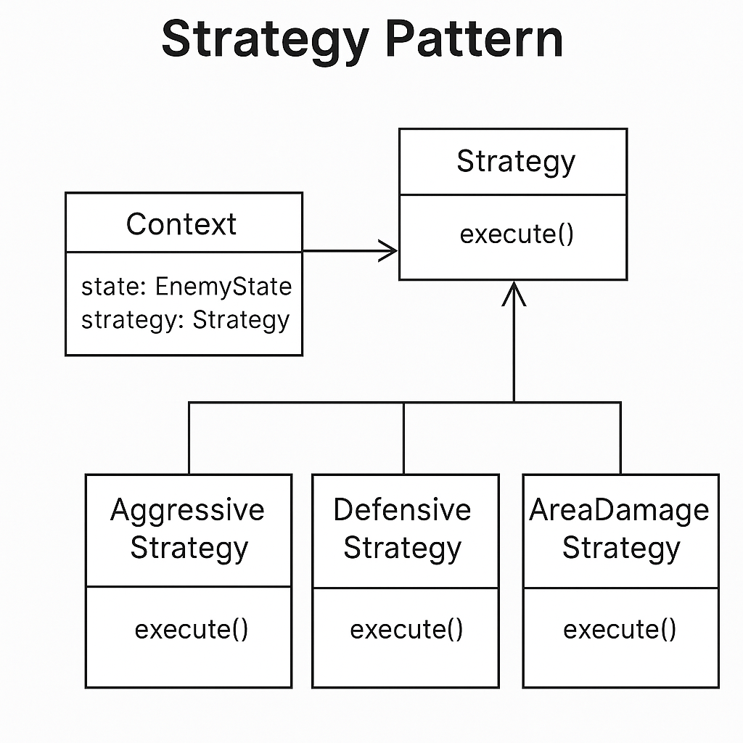

# 5.11 Factory Pattern

The Factory Pattern is used extensively throughout the project to encapsulate the creation logic of enemies, heroes, bonuses, and obstacles. This design improves modularity, supports the Open/Closed Principle, and isolates complexity from the Main class.

Multiple factory classes were implemented, including:

* EnemyFactory: generates enemies based on difficulty, assigning strategies dynamically.
* BonusFactory: selects bonus types and even includes randomized penalties in HARD mode.
* ObstacleFactory: creates traps and walls with scalable impact.
* TitanHeroFactory: provides the correct team composition (Titan or dual heroes) according to game difficulty.

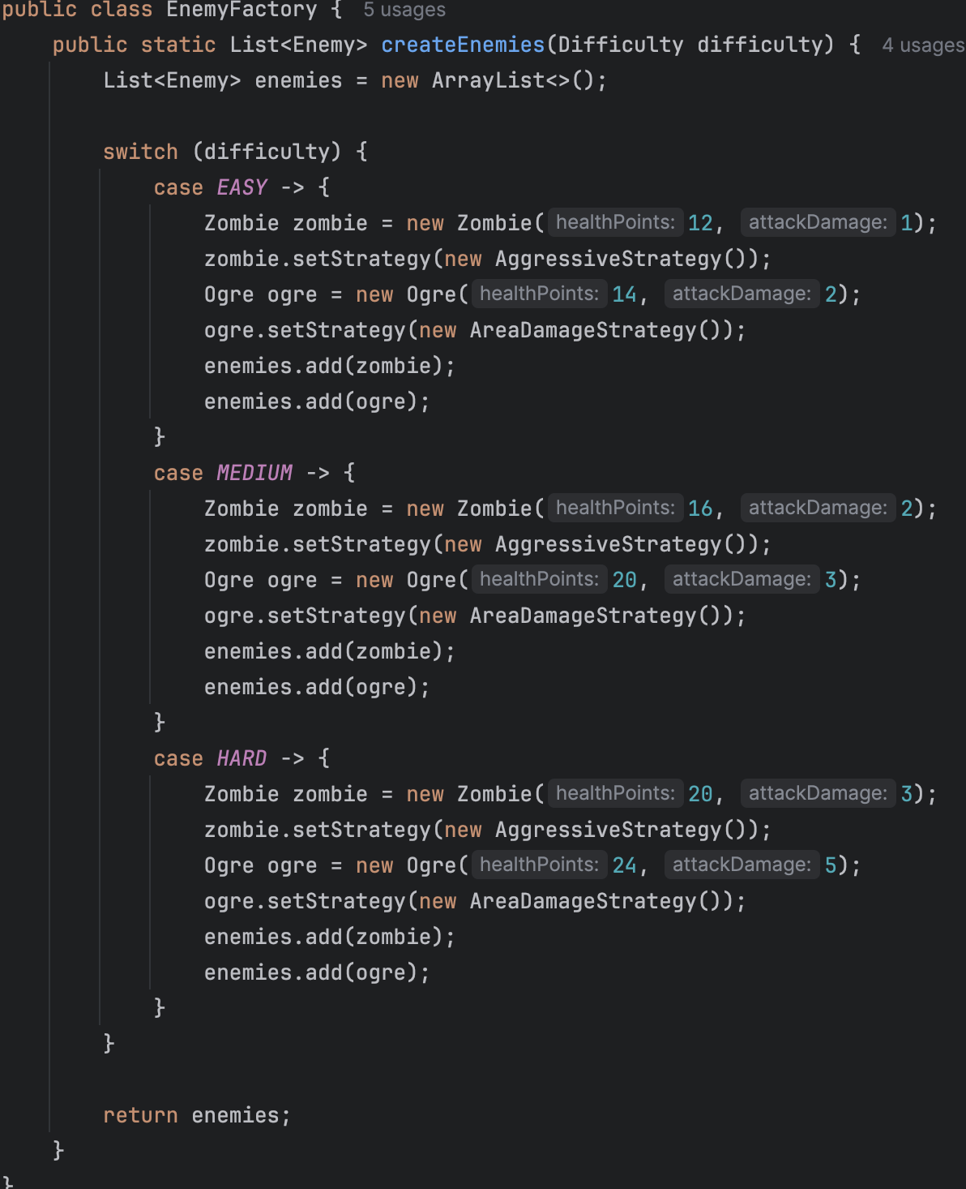

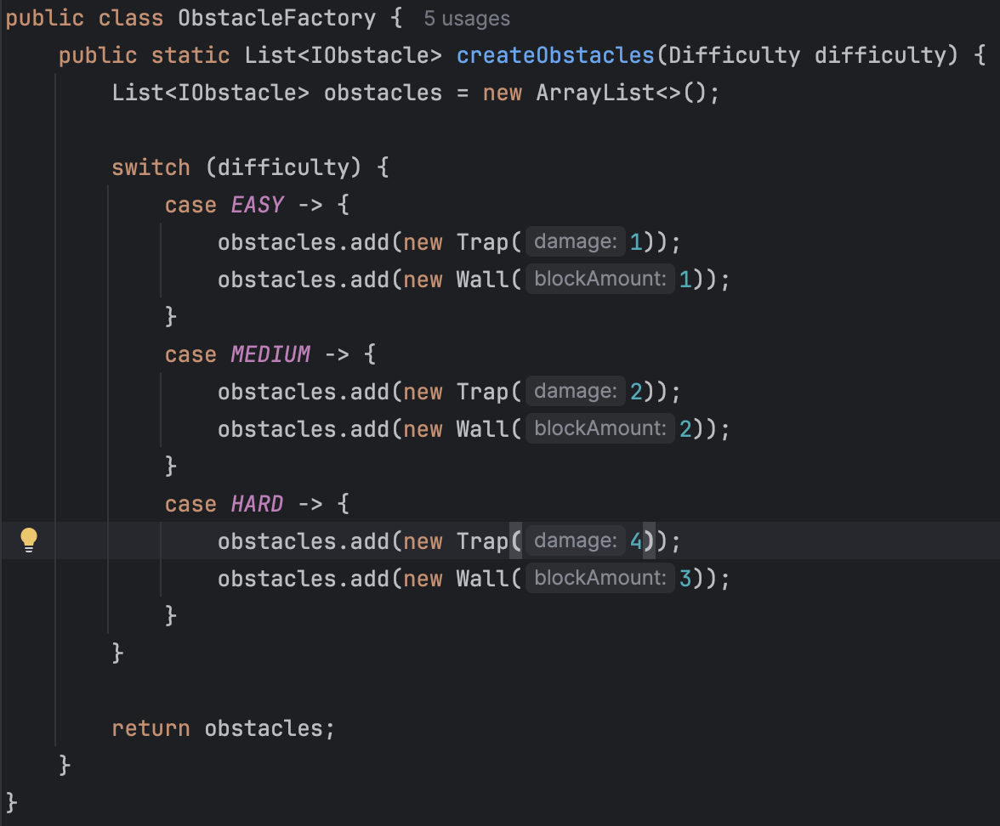

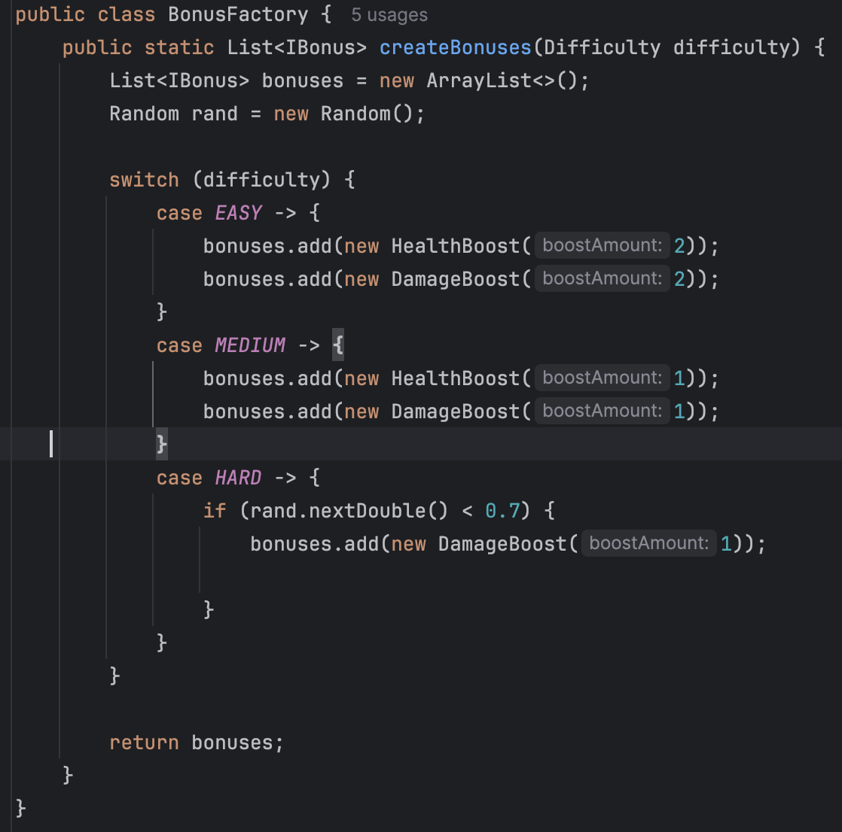

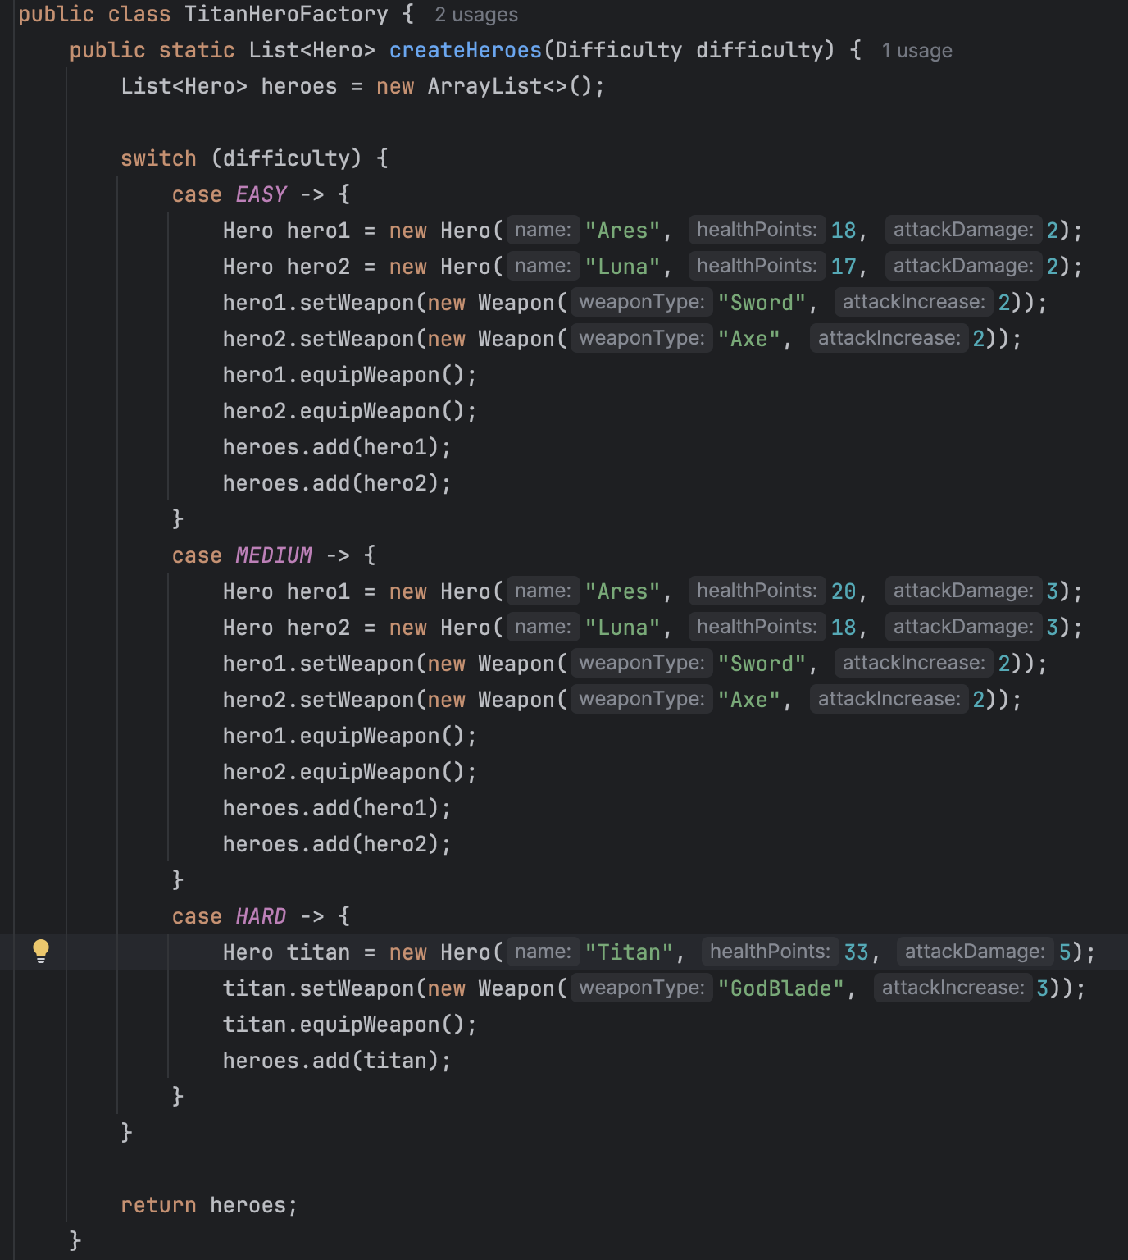

# 6.1 Multiple Players

The system supports multiple heroes, each with independent state and behavior. They participate in a shared battle loop and are managed using List<Hero>. While there is no manual input, this simulates local multiplayer logic where all heroes act in turn.





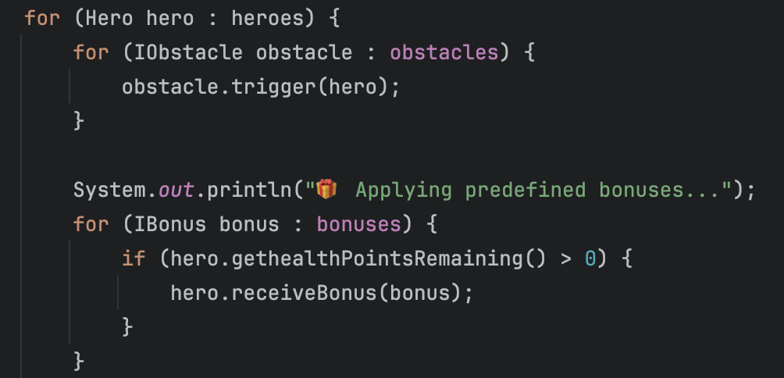

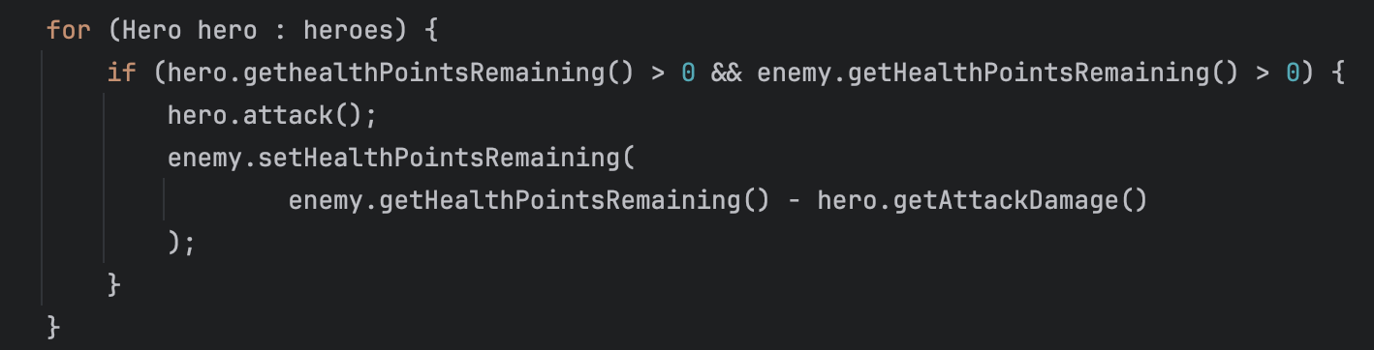

# 6.2 AI-Assisted Gameplay

All combat actions are automatically performed through predefined AI logic:

* Heroes auto-attack enemies
* BonusSelector uses the hero’s condition to determine bonus type
* Critical hits and special attacks are triggered probabilistically
* Enemies use assigned combat strategies through the Strategy Pattern:
* AggressiveStrategy: attacks the strongest hero
* DefensiveStrategy: attacks the weakest hero
* AreaDamageStrategy: attacks all living heroes simultaneously

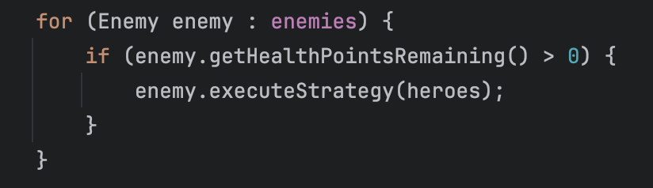

Enemies adapt their behavior using an internal EnemyState, evaluated each round. Based on this state, they may attack aggressively, defensively, or flee entirely.

# 6.3 Environmental Obstacles

Each level includes environmental elements that influence gameplay difficulty through damage or penalty. Obstacles are dynamically generated using ObstacleFactory based on the current difficulty level.

There are two main types of obstacles:

* Trap

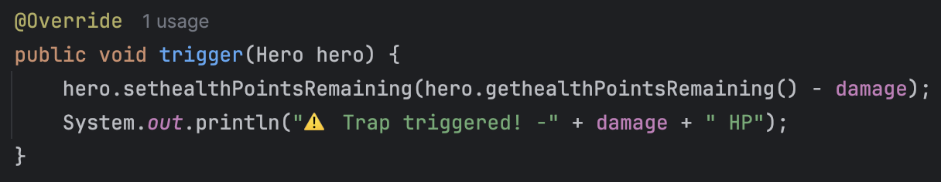

* Wall

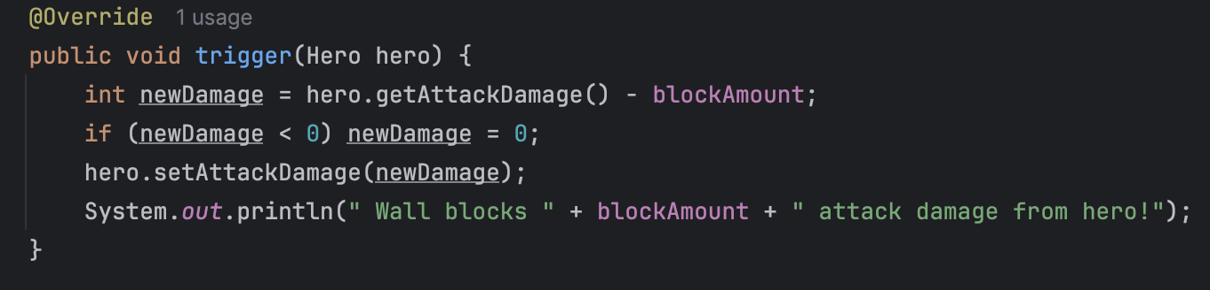

The strength of each obstacle is determined by the difficulty setting:

* In **EASY**: mild effects ( -1 HP, block 1 ATK)
* In **HARD**: severe effects ( -4 HP, block 3 ATK)

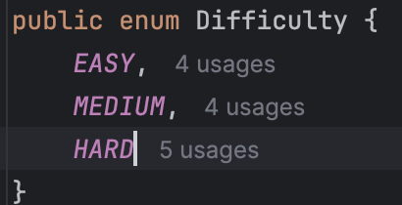

Enum Difficulty class defines the set of unique constant values (EASY,MEDIUM,HARD). Only the constants defined in the enum can be assigned to variables of that enum type which is Difficulty in this case.

# 6.4 Dynamic Bonuses

Heroes receive both:

* Predefined bonuses (+1 HP, +1 ATK)
* Smart bonuses, chosen dynamically based on their current health
* BonusSelector.java:

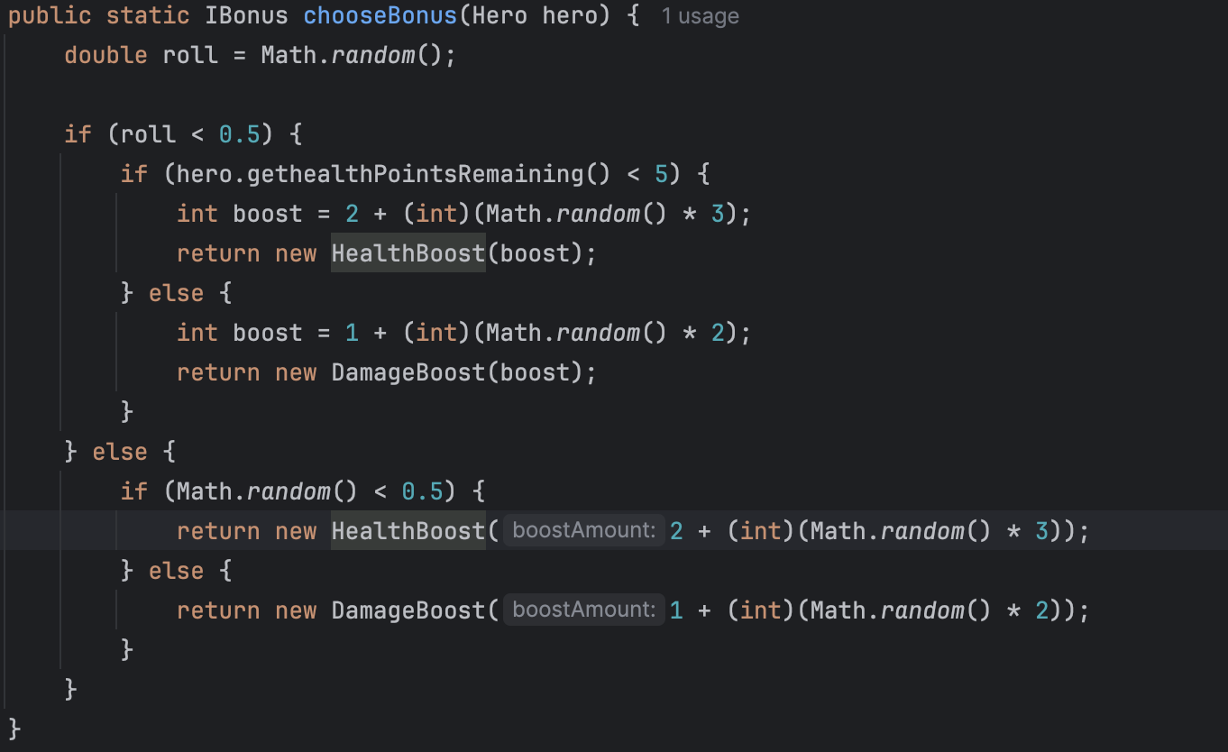

* Level.java:

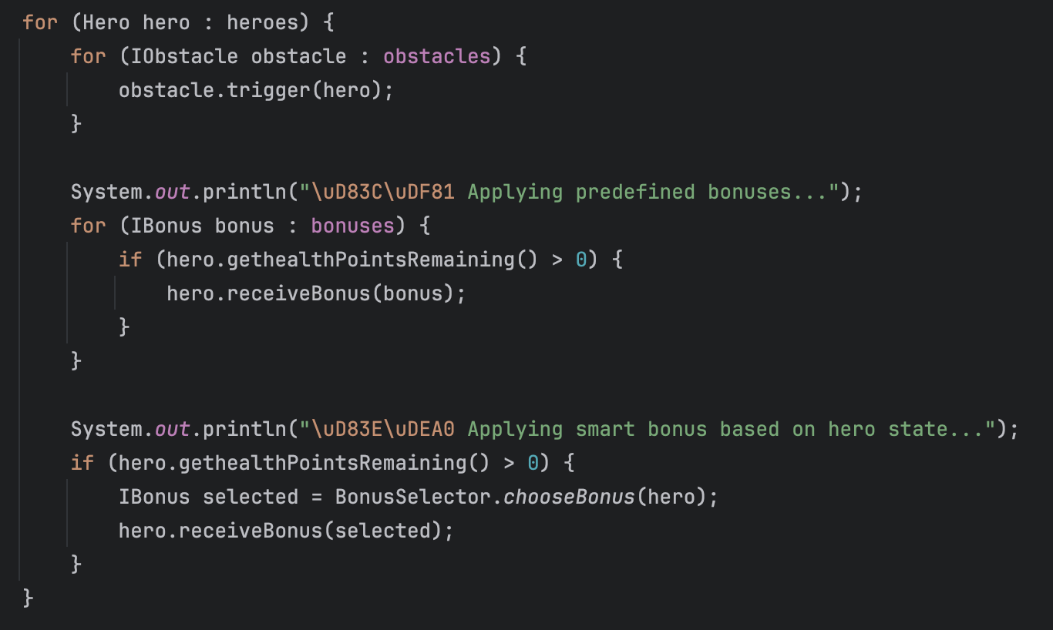

# 6.5 Level Progression System

Levels are modularly created using the Level class and managed by LevelManager. Each level may have its own configuration of:

* Enemies
* Obstacles
* Bonuses
* Difficulty level (EASY, MEDIUM, HARD)

The hero team composition dynamically changes based on difficulty:

* In EASY and MEDIUM: two heroes (Ares and Luna)
* In HARD: a single powerful hero (Titan)
* Main.java



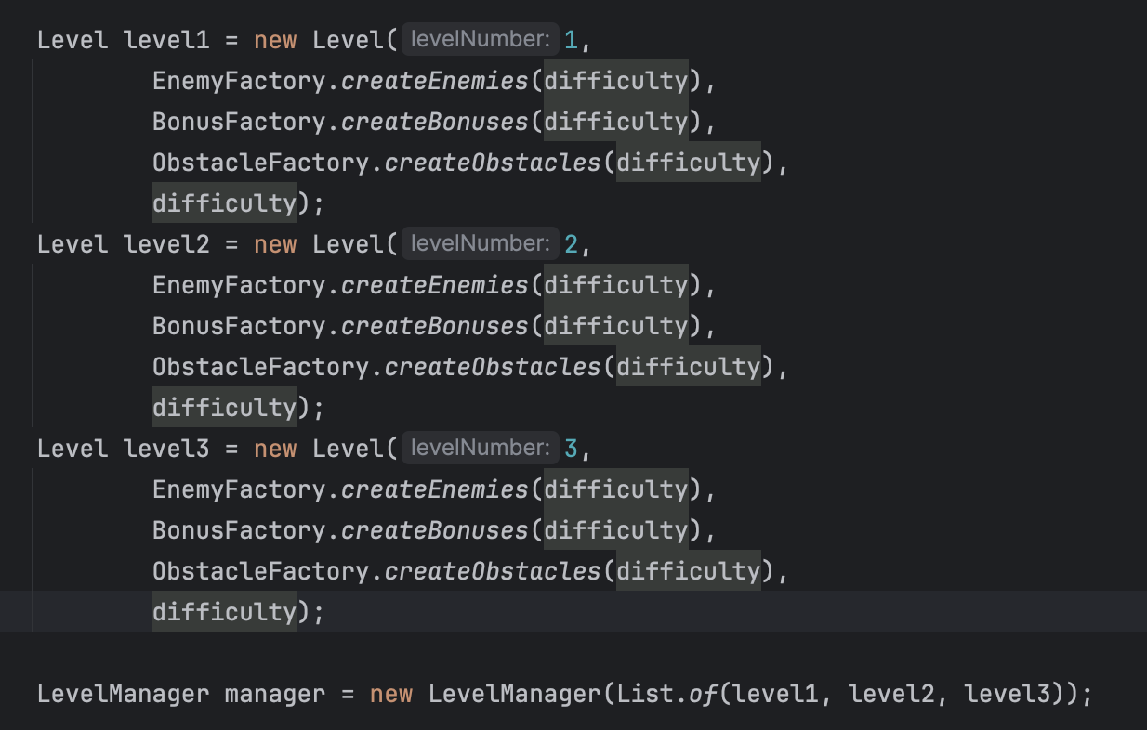

* LevelManager.java

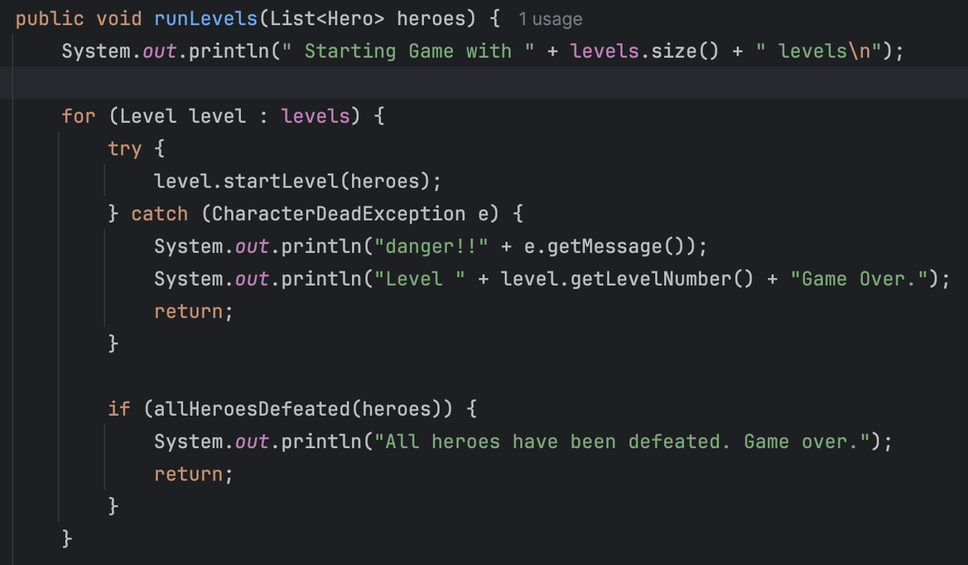

# 6.6 Exception Handling and Game Logic Enforcement

The game defines a custom CharacterDeadException, which is thrown when a hero dies. This ensures:

* Immediate termination of the level
* Clean and safe game-over state
* Clear separation of gameplay and control logic
* CharacterDeadException.java:

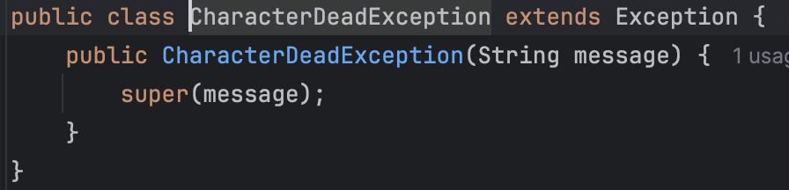

* Thrown in Level.java:



* Caught in LevelManager.java:

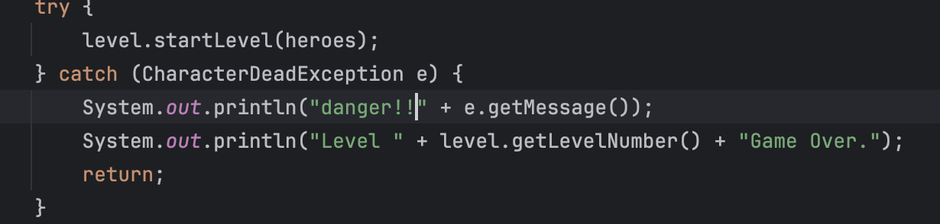

# 7. Conclusion

Battle Arena is a complete implementation of object-oriented programming principles. It demonstrates the power of encapsulation, abstraction, and polymorphism in building flexible, extensible systems.Difficulty scaling and dynamic team formation via TitanHeroFactory support gameplay variety and clean code separation.